# Quality of Software

## Definition:

**# Source**: **Chatgpt (GPT-5-Standard) at [8/19/2025]**The **quality of software** is the degree to which a software product meets its **requirements, user expectations, and industry standards** while being **reliable, maintainable, efficient, and usable**.

In simple terms → **“Good quality software does what it is supposed to do, works well, is easy to use, and can be maintained and extended without major issues.”**

## 🔹 Key Characteristics of Software Quality

**# Source**: **Chatgpt (GPT-5-Standard) at [8/19/2025]**

(Defined by standards like **ISO/IEC 25010** and **IEEE**)

1. **Functionality** – The software provides the required features and functions correctly.  
   * Example: A banking app correctly transfers money.
2. **Reliability** – The software performs consistently under defined conditions without failure.  
   * Example: ATM software doesn’t crash when multiple users access it.
3. **Usability** – Easy to learn and use, with a good user interface (UI/UX).  
   * Example: A new user can quickly learn to use a ride-hailing app.
4. **Efficiency (Performance)** – Uses system resources (CPU, memory, network) optimally.  
   * Example: A video player streams smoothly without lag.
5. **Maintainability** – Easy to fix defects, update, or improve.  
   * Example: Developers can add new payment methods to an e-commerce site easily.
6. **Portability** – Can be used in different environments (OS, browsers, devices).  
   * Example: A web app works on Chrome, Edge, and Firefox.
7. **Security** – Protects data and resists unauthorized access.  
   * Example: A healthcare app encrypts patient records.

## 📏 How to Measure Quality of Software

**# Source**: **Chatgpt (GPT-5-Standard) at [8/19/2025]**

Measuring **software quality** means using **quantitative metrics** (numbers) and **qualitative methods** (reviews, user feedback) to evaluate how well the software meets its goals.

### Types

#### 🔹 1. Functionality Metrics

**# Source**: **Chatgpt (GPT-5-Standard) at [8/19/2025]**

* **Requirement Coverage** → % of requirements implemented and tested.  
  + Example: *95% of requirements are covered by test cases.*
* **Defect Density** → Number of defects per size (e.g., defects per 1,000 LOC or per function point).  
  + Formula:

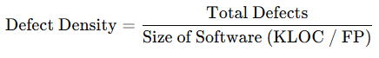  
Defect Density=Total DefectsSize of Software (KLOC / FP)\text{Defect Density} = \frac{\text{Total Defects}}{\text{Size of Software (KLOC / FP)}}

#### 🔹 2. Reliability Metrics

**# Source**: **Chatgpt (GPT-5-Standard) at [8/19/2025]**

* **Mean Time Between Failures (MTBF)** → Average time between two failures.
* **Mean Time To Failure (MTTF)** → Expected time to the first failure.
* **Defect Leakage** → % of defects found by users after release.  
  + Formula:

  
Defect Leakage=Defects found after releaseTotal defects×100\text{Defect Leakage} = \frac{\text{Defects found after release}}{\text{Total defects}} \times 100

#### 🔹 3. Usability Metrics

**# Source**: **Chatgpt (GPT-5-Standard) at [8/19/2025]**

* **User Error Rate** → How often users make mistakes while using the software.
* **User Satisfaction Score (SUS, CSAT, NPS)** → Based on surveys/feedback.
* **Task Completion Rate** → % of tasks completed successfully by users.

#### 🔹 4. Performance (Efficiency) Metrics

**# Source**: **Chatgpt (GPT-5-Standard) at [8/19/2025]**

* **Response Time** → Time taken to process a request.
* **Throughput** → Number of transactions handled per second.
* **Resource Utilization** → CPU, memory, bandwidth usage under load.

#### 🔹 5. Maintainability Metrics

**# Source**: **Chatgpt (GPT-5-Standard) at [8/19/2025]**

* **Code Complexity (Cyclomatic Complexity)** → Measures how complex the code is.
* **Maintainability Index** → Score (0–100) showing how easy it is to maintain code.
* **Defect Fix Time** → Average time to fix defects.

#### 🔹 6. Portability Metrics

**# Source**: **Chatgpt (GPT-5-Standard) at [8/19/2025]**

* **Compatibility Testing Pass Rate** → % of environments where software works correctly.
* **Platform Coverage** → Number of supported OS/devices/browsers.

#### 🔹 7. Security Metrics

**# Source**: **Chatgpt (GPT-5-Standard) at [8/19/2025]**

* **Number of Vulnerabilities** found in testing or after release.
* **Time to Patch** → Time taken to fix a security issue.
* **Penetration Testing Success Rate** → How many attacks were resisted.

### ✅ Example in Practice:

**# Source**: **Chatgpt (GPT-5-Standard) at [8/19/2025]**

Suppose you are testing an **E-commerce Website**:

* **Functionality** → 98% of requirements implemented.
* **Reliability** → MTBF = 20 days, Defect Leakage = 3%.
* **Usability** → 90% task completion, SUS score = 80/100.
* **Performance** → Avg response time = 1.2s, throughput = 500 orders/min.
* **Security** → 2 critical vulnerabilities found and patched in 24 hrs.

This shows the **quality status** in measurable terms.

👉 In short:  
 **Software quality is measured using metrics like defect density, MTBF, usability scores, performance benchmarks, maintainability index, and security vulnerabilities.**

### 📊 Software Quality Measurement Table

**# Source**: **Chatgpt (GPT-5-Standard) at [8/19/2025]**

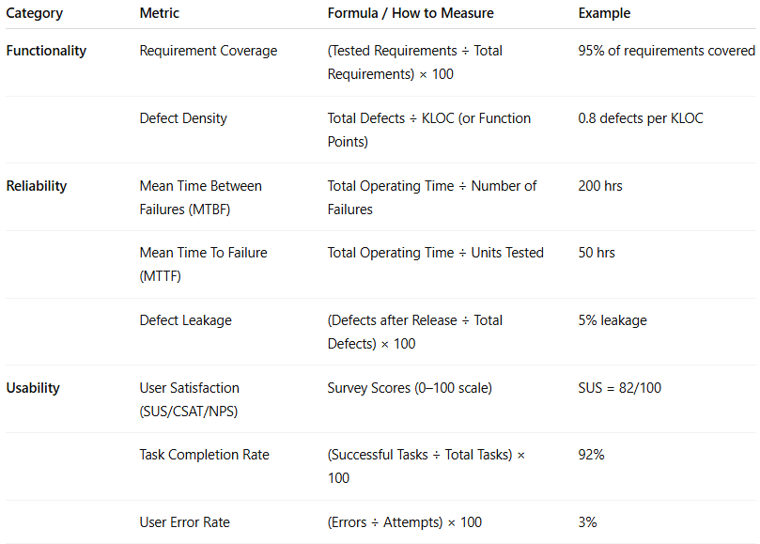

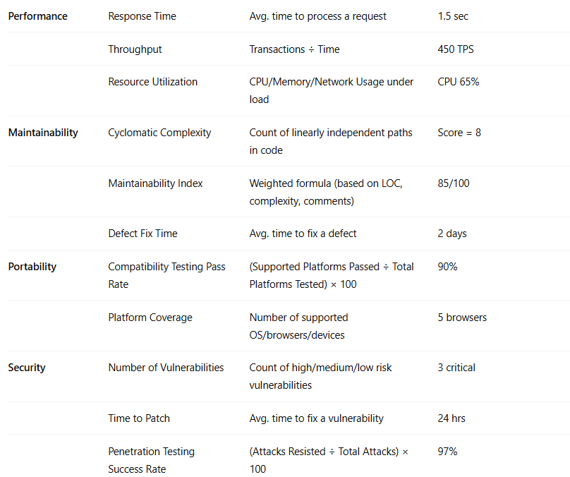

| **Category** | **Metric** | **Formula / How to Measure** | **Example** |
| --- | --- | --- | --- |
| **Functionality** | Requirement Coverage | (Tested Requirements ÷ Total Requirements) × 100 | 95% of requirements covered |
|  | Defect Density | Total Defects ÷ KLOC (or Function Points) | 0.8 defects per KLOC |
| **Reliability** | Mean Time Between Failures (MTBF) | Total Operating Time ÷ Number of Failures | 200 hrs |
|  | Mean Time To Failure (MTTF) | Total Operating Time ÷ Units Tested | 50 hrs |
|  | Defect Leakage | (Defects after Release ÷ Total Defects) × 100 | 5% leakage |
| **Usability** | User Satisfaction (SUS/CSAT/NPS) | Survey Scores (0–100 scale) | SUS = 82/100 |
|  | Task Completion Rate | (Successful Tasks ÷ Total Tasks) × 100 | 92% |
|  | User Error Rate | (Errors ÷ Attempts) × 100 | 3% |
| **Performance** | Response Time | Avg. time to process a request | 1.5 sec |
|  | Throughput | Transactions ÷ Time | 450 TPS |
|  | Resource Utilization | CPU/Memory/Network Usage under load | CPU 65% |
| **Maintainability** | Cyclomatic Complexity | Count of linearly independent paths in code | Score = 8 |
|  | Maintainability Index | Weighted formula (based on LOC, complexity, comments) | 85/100 |
|  | Defect Fix Time | Avg. time to fix a defect | 2 days |
| **Portability** | Compatibility Testing Pass Rate | (Supported Platforms Passed ÷ Total Platforms Tested) × 100 | 90% |
|  | Platform Coverage | Number of supported OS/browsers/devices | 5 browsers |
| **Security** | Number of Vulnerabilities | Count of high/medium/low risk vulnerabilities | 3 critical |
|  | Time to Patch | Avg. time to fix a vulnerability | 24 hrs |
|  | Penetration Testing Success Rate | (Attacks Resisted ÷ Total Attacks) × 100 | 97% |

## 🔍 Software Quality vs Software Testing

**# Source**: **Chatgpt (GPT-5-Standard) at [8/19/2025]**

# 

| **Aspect** | **Software Quality** | **Software Testing** |
| --- | --- | --- |
| **Definition** | Overall measure of how well the software meets requirements, user needs, and standards (ISO/IEC 25010, etc.). | Process of evaluating the software through execution of tests to detect defects and verify functionality. |
| **Scope** | Broad – covers all aspects (functionality, performance, usability, reliability, maintainability, security, portability). | Narrow – focuses mainly on finding defects and validating functionality. |
| **Goal** | Deliver a product that is reliable, secure, efficient, and user-friendly. | Identify and fix defects before release to improve product quality. |
| **When Applied** | Throughout the **entire SDLC** (planning, design, coding, testing, deployment, maintenance). | Primarily during the **testing phase**, but can also be integrated early (Shift-Left Testing). |
| **Activities Involved** | - Requirements review- Design/code reviews- Risk management- Metrics tracking- Process improvement- Testing as part of quality activities | - Writing test cases- Executing tests- Logging and retesting defects- Test reporting |
| **Who is Responsible** | **Everyone in the team** (developers, testers, product owners, business analysts, operations). | **QA/Testers** (with support from developers and automation tools). |
| **Measurement** | Measured using **quality metrics** (defect density, MTBF, user satisfaction, maintainability index, etc.). | Measured using **test metrics** (test coverage, pass/fail rate, defect detection rate, etc.). |
| **Outcome** | High-quality software that meets customer expectations and business goals. | Identified defects that, when fixed, contribute to better quality. |

✅ **In short:**

* **Software Quality** = *the ultimate goal* (what we want to achieve).
* **Software Testing** = *one of the key activities* to help achieve that goal.

Would you like me to also create a **real-world analogy** (like comparing it to a car factory – quality = entire car performance, testing = crash tests/inspections) to make it easier to remember?

## 🔹 Why Software Quality is Important?

**# Source**: **Chatgpt (GPT-5-Standard) at [8/19/2025]**

* Prevents **failures** and reduces **defects**.
* Improves **customer satisfaction** and trust.
* Saves **time and cost** in the long run (less rework).
* Ensures **compliance** with regulations (finance, healthcare, etc.).
* Makes the product **competitive** in the market.

✅ **In summary:** **Software quality** is about building software that is **functional, reliable, secure, efficient, and user-friendly**, while also being **easy to maintain and adapt** over time.